LEAP Review Tools
  - A guide for everyday use
4 August 2026

Welcome
These two tools help you check a LEAP model against the source data it should agree with.
The balance review produces an Excel workbook that shows, cell by cell, where your LEAP energy balance differs from the source data — and by how much. It is the tool to reach for when you want to know what to fix.
The dashboard produces a set of interactive web pages comparing LEAP against ESTO and the 9th Outlook across every sector and fuel. It is the tool to reach for when you want to see the whole picture, or show it to someone else.
There is nothing to install. Everything the tools need is already in the folder you were sent. You give them your LEAP exports, and they give you back a workbook or a dashboard.
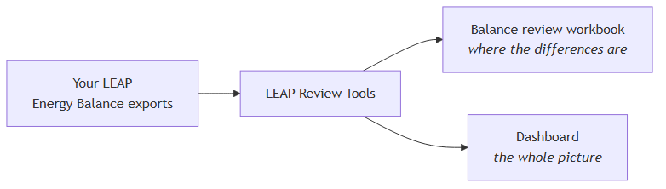

Before you start
Extract the folder somewhere simple. C:\Tools\ is ideal. Avoid extracting it deep inside a OneDrive or Documents folder — long paths cause problems.
Windows will warn you the first time. You may see a blue box saying “Windows protected your PC”. This is expected: the program has not been registered with Microsoft. Click More info, then Run anyway. You only need to do this once.
The APERC security software will also try to stop you. Just say ‘Allow once’ like in the image below: 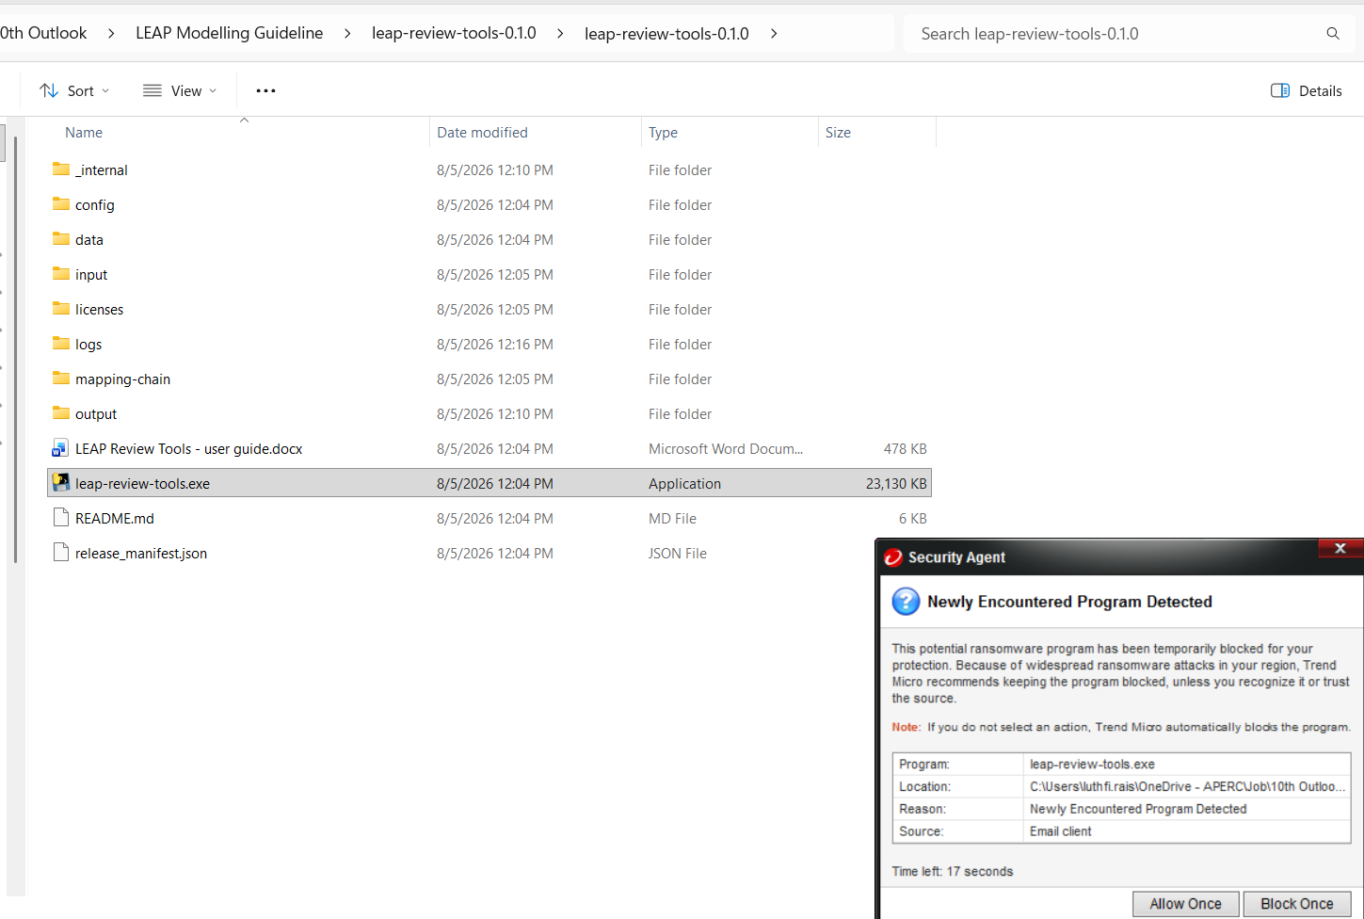
You do not need Excel to run the tools. You only need it to open the workbook afterwards. When you do open it, Excel will recalculate the sheet — that is normal and takes a moment.
To work with the tools, open the folder in File Explorer, hold Shift, right-click in an empty area, and choose Open PowerShell window here. You will type short commands there. Each one in this guide can be copied exactly as written.

Exporting results from LEAP
Make sure that you set Units to Petajoules and Detail to Level 2.
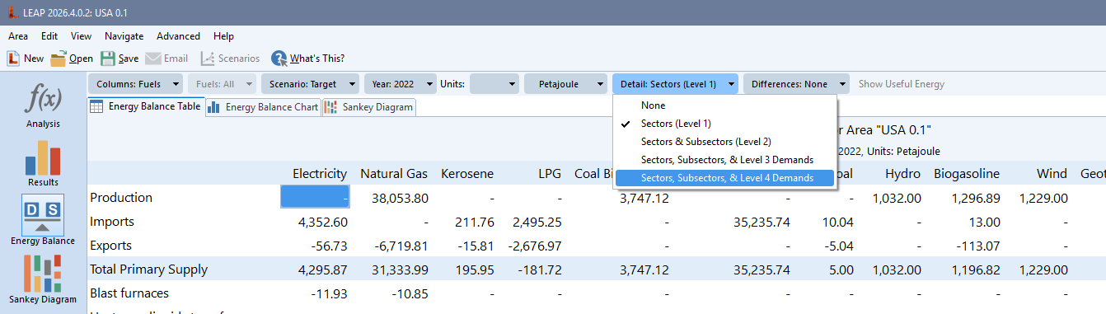Press the excel symbol and ‘All’. From previous experiences it will typically take 30minutes to complete for 2022-2060 in level 2 detail.
A Level 1 export flattens everything into single rows, which leaves nothing to compare. The tools check for this and will tell you plainly if an export is too shallow, rather than producing a misleading result.
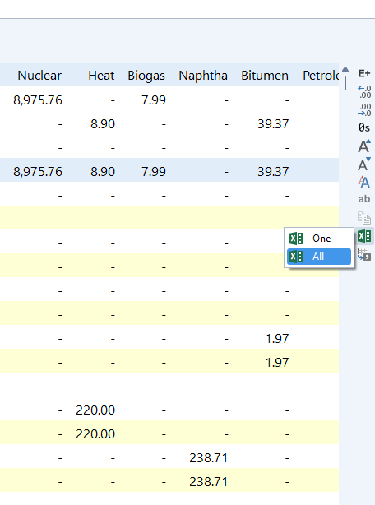

Putting your files in
There is one folder you need to care about: input\leap balances exports.
A folder is already there for every economy. Put each economy’s LEAP Energy Balance exports into its folder — you do not need to create anything.
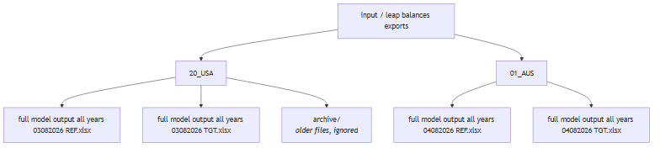
This is the same layout the modelling team uses, so you can copy a folder straight across in either direction.

Naming your files
Two things need to be in the filename:
- a four-digit date, day then month — 0804 for the 8th of April;
- a scenario code — REF or TGT. Reference and Target also work.
Anything else in the name is up to you, and the order does not matter. All of these are fine:
0804 TGT.xlsx
TGT 0804.xlsx
USA balance 0804 Target.xlsx
full model output all years 04082026 TGT.xlsx
A longer date works too, so 04082026 is read the same as 0804.
If you have several files for one economy and scenario, the newest date wins. That is what the date is for. You do not have to delete the older ones — leave them and the tools will use the most recent. If you would rather they were out of the way, make a folder called archive inside the economy folder and move them there; anything in archive is ignored completely.
If a file cannot be matched to a scenario, the tools read the workbook itself to work it out, so a slightly different name usually still works. Run list to see what has actually been picked up.

Checking it can see your files
Before running anything properly, ask the tools what they can find:
.\leap-review-tools.exe list
You will get something like this:
LEAP balance exports in: C:\Tools\leap-review-tools-0.1.0\input\leap balances exports
01_AUS
Reference full model output all years 04082026 REF.xlsx [2022-2060]
Target full model output all years 04082026 TGT.xlsx [2022-2060]
20_USA
Reference full model output all years 03082026 REF.xlsx [2022-2060]
Target full model output all years 03082026 TGT.xlsx [2022-2060]
Each economy is listed with the file chosen for each scenario and the years that file covers. This is the quickest way to confirm your files are named correctly and in the right place.
If a file is named in a way the tools do not recognise, it says so here rather than quietly ignoring it. That is usually a typo in the date or the scenario.

Building a balance review
This gives you the Excel workbook showing where LEAP and the source data disagree.
Step 1. Decide which economy, scenario and year you want to review. Most reviews are for the base year, 2022.
Step 2. Run the command, changing the economy, scenario and year to suit:
.\leap-review-tools.exe balance-review-from-export --economy 20_USA --scenario Target --year 2022
You do not have to tell it which file to use — it finds the right export for that economy and scenario itself.
Step 3. Wait. It will print its progress as it works. It reads your export, compares every value against the source data, and builds the workbook.
Step 4. Open the result:
output\20_USA\balance_review\balance_review_20_USA_tgt_2022.xlsx
The next section explains what you are looking at.
If you already have a diagnostics folder from the modelling team, you can use it directly instead — that is the balance-review command, and it takes the folder as --diagnostics-directory. Ask whoever sent you the tools if you are not sure which applies to you.

Reading the balance-review workbook
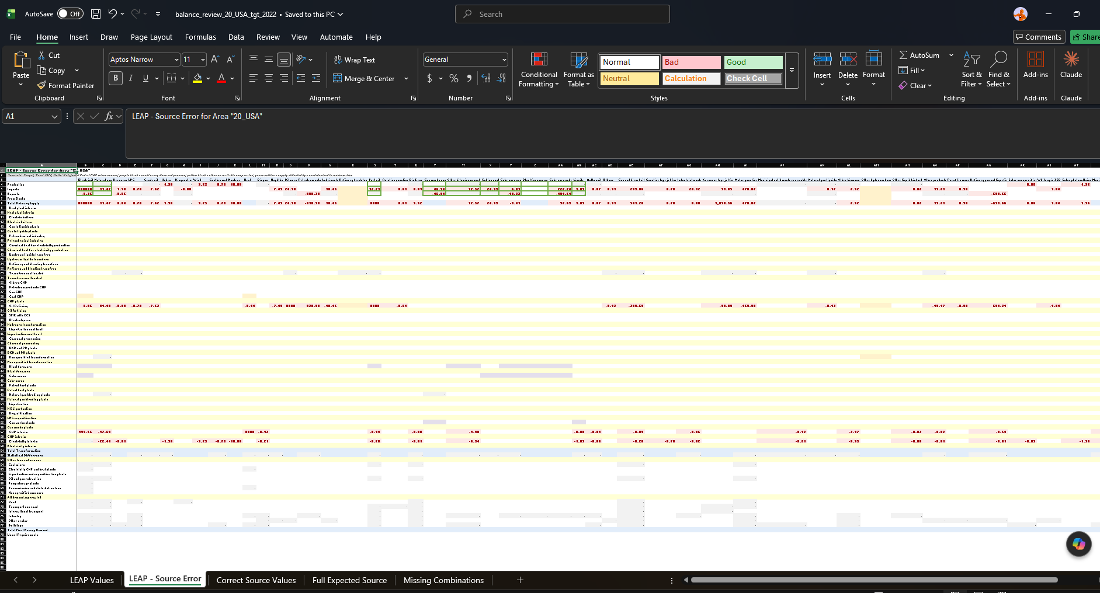

How the comparison is made
You export the balance table from LEAP. The tools then compare those results against the original source data and identify every difference. The workbook is that comparison, laid out in the shape of the balance table you already know.
So a difference is a disagreement between the model and the source — not a verdict about which one is wrong.

The five sheets
They are meant to be read in order, and each answers a different question.
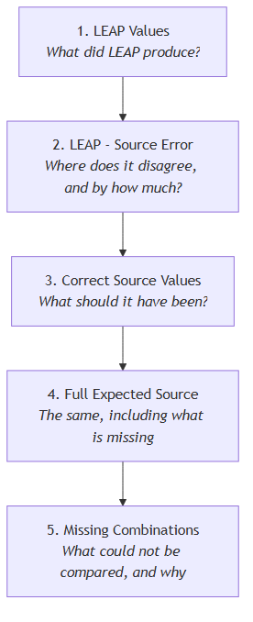
LEAP Values is your energy balance exactly as LEAP produced it, converted to petajoules. Nothing has been changed. Use it to get your bearings — the rows and columns are the ones you already know.
LEAP - Source Error is the heart of it. Each cell shows LEAP minus the source. A red cell means they disagree, and the number is the size of the gap. A grey zero means they agree. This is your worklist: start with the largest red numbers.
Correct Source Values shows what the source data says each cell should be. When you want to know not just that something is wrong but what it ought to be, this is the sheet.
Full Expected Source is the same again, but it also greys out the cells that do not exist in your balance structure at all. It answers “is this missing, or is it just not applicable here?”
Missing Combinations lists everything that could not be compared, one row per case, with the reason and a suggested interpretation. Read this before concluding that a blank cell means zero — it usually does not.

Where the differences come from
We are keeping track of known issues from the baseline seed’s here https://aperc.sharepoint.com/:w:/s/Outlook10/IQDaz8y5X2yPRa6UbywCpZkbATJ9_SdmdwbnNKTO_2iPga0?e=aS4gkv so check that for issues first.
A difference on the error sheet is not automatically a mistake in LEAP. It is a disagreement between two things, and it can come from any of three places.
1. LEAP is not calculating what the comparison expects. The fix is either to change the LEAP calculation method — the supply rules Luthfi teaches, for example — or to change the inputs generated for LEAP so it produces the intended result.
2. The comparison itself is wrong. The mapping between the source data and the LEAP balance categories may be incorrect, or there may be a problem in the code applying it. These are being worked through steadily, and fixing them improves several other parts of the process at the same time.
3. The baseline seed values are wrong. Then the seed generation needs fixing and the seed files rebuilding, as is being done for refining.
Worth holding all three in mind before changing anything: the most common instinct is to assume the first, and a good share of what turns up is the second.

Building a dashboard
This gives you interactive web pages comparing LEAP against ESTO and the 9th Outlook.
.\leap-review-tools.exe dashboard-from-export --economy 20_USA
This one takes longer — a few minutes — because it reads every export you have for that economy, works out the comparison, and then draws several hundred charts. It prints its progress as it goes.
When it finishes, open:
output\20_USA\dashboard\20_USA\dashboards\index.html
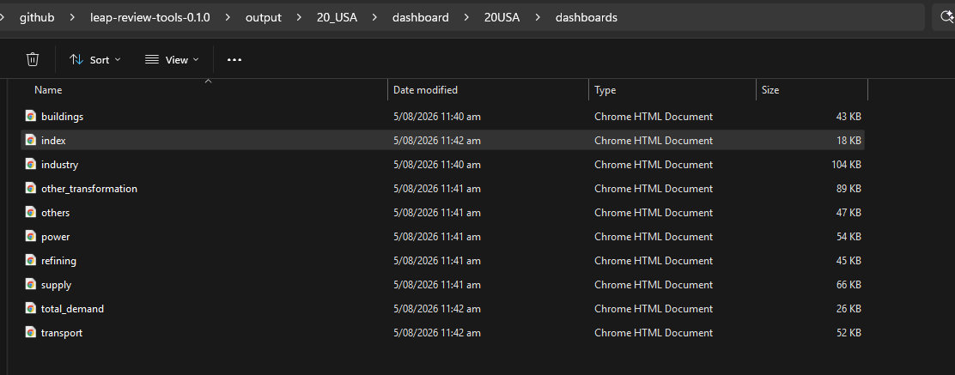
It opens in your web browser. No internet connection is needed; everything is in the folder.
Down the side you will find a page per sector. Each chart shows up to three series: what LEAP produced, what ESTO recorded, and what the 9th Outlook projects. Historical years compare against ESTO; projection years compare against the 9th. You can click series names in the legend to hide or show them.
Some sector pages may be missing. That is deliberate: if LEAP has no separately modelled detail for a sector in that economy, a page would be misleading, so it is left out. The run tells you which ones and why.
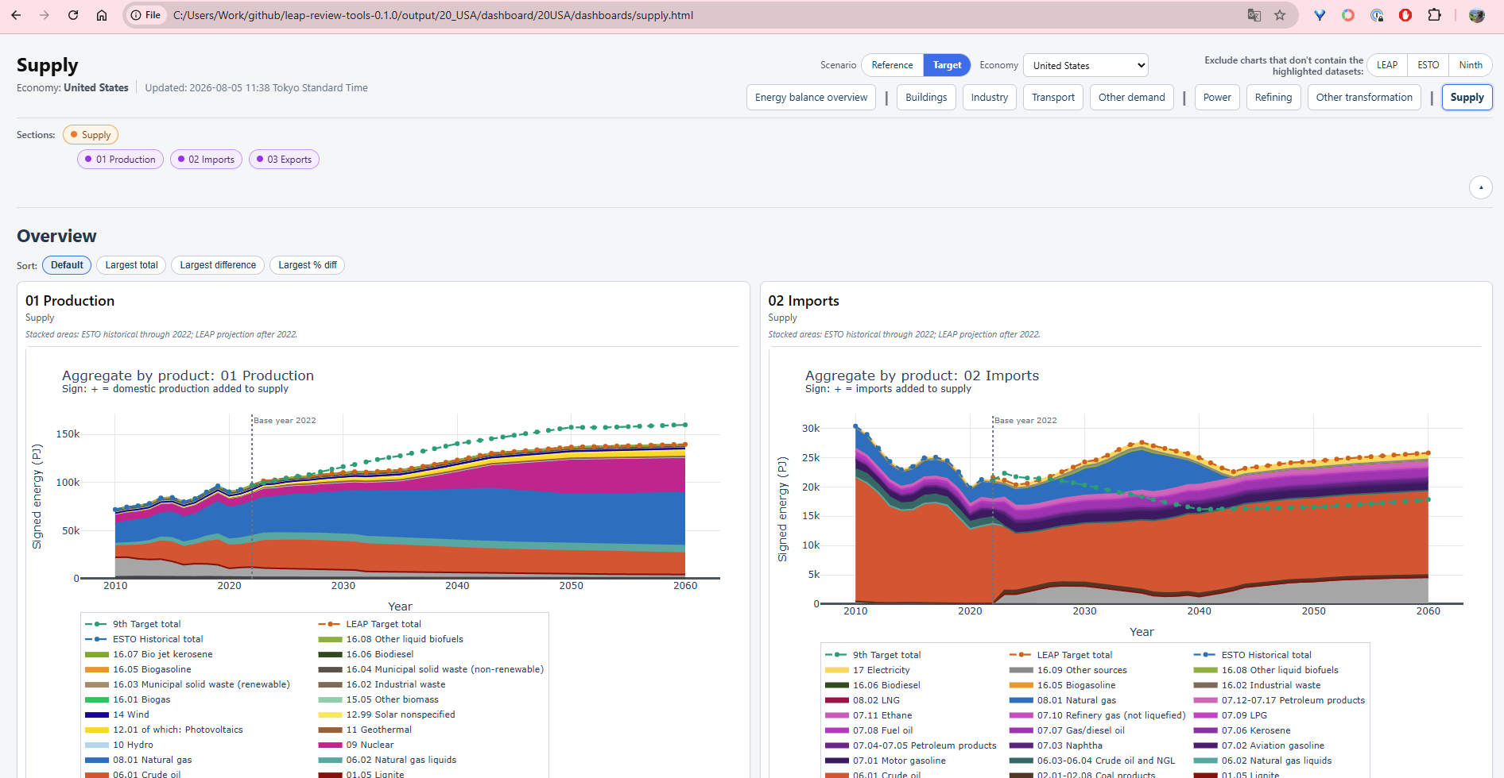
The example from the dashboard above shows how the production and imports are different compared to 9th and ESTO, based on the LEAP export file you provided.

Where your results go
Everything is grouped by economy, so nothing you produce overwrites anything else.
output/
20_USA/
balance_review/ workbooks for the USA
dashboard/ the USA dashboard
01_AUS/
balance_review/
dashboard/
You can review the USA today and Australia tomorrow and both remain in place. Within an economy, workbooks for different scenarios and years sit side by side, because the scenario and year are part of each filename.
Beside your results you will find a run_records folder. Each run leaves a dated record in there showing exactly which files it used and when. You can ignore it day to day — it is there so that months later you can answer “which export did this come from?” with certainty rather than memory.

If something goes wrong
The tools try to explain problems in plain language rather than showing an error you would need a programmer to read. Work through these in order.
Start here. This confirms the folder is complete and working:
.\leap-review-tools.exe selfcheck
You want to see result : OK.
Read the validation report. Every run leaves one in its run_records folder, whether it succeeded or not. If a run stopped, this file says which input was wrong and what was expected. Most problems are answered here.
Check what it can see. Run list again. A surprising number of problems are a file in the wrong folder or a date typed differently from the filename.
If a run failed, no result was produced. The tools do not write a partial workbook or a half-finished dashboard. You will not accidentally use a broken output.
Send a support bundle. Add --support-bundle to any command and you get a ZIP in the output folder containing the run record, the checks that ran, and the logs. It deliberately contains none of your data, so it is safe to email.

Updating settings without a new version
Beside the program there is a folder called config. It holds the settings the tools use: which sectors appear on which dashboard page, the colours, the series labels, and the mapping information behind the comparison.
If your modelling team sends you a replacement for one of these files, drop it in and run again. The change takes effect immediately — you do not need a new version of the program. Each run records which settings it used, so a result can always be traced back to the exact files behind it.
If something behaves unexpectedly after a settings change, that record is the first thing to check.

About the reference data
Your LEAP model is compared against two reference datasets that come with the tools: the ESTO historical data, and the 9th Outlook projections. You do not need to supply either — they are already in the folder.
The ESTO data is reissued once a year, and each new issue moves the base year along. The version in your copy is the 2024 issue, with a base year of 2022. When the 2026 issue arrives the base year becomes 2024, and so on.
You can use a newer ESTO file without waiting for a new version of the tools. Point either command at it:
.\leap-review-tools.exe dashboard-from-export --economy 20_USA --esto-table-path "input\00APEC_2026_low_with_subtotals.csv"
Both tools then use your file, and the base year moves with it automatically — the tools read it from the file rather than being told. The comparison rows are rebuilt from your data the first time you use a given file, which adds a couple of minutes; after that it is remembered.
Two things worth knowing. An ESTO update does not change the projections — the 9th Outlook is finished and will not be reissued. In future this comparison may be run against a different projection instead, with its own mappings to the LEAP and ESTO data; the tools are built to accommodate that when it happens. And each run records which file it used, so a result can always be traced back to the data behind it.
If you would rather not manage this yourself, that is fine too: your modelling team will send a new version of the tools with the newer data already in it.

Please never edit the reference data
It is a plain spreadsheet file, so it can be opened and changed — but please don’t, even to correct something that looks wrong.
The tools already add the rows a particular ESTO issue is missing. Newer categories such as datacentres and hydrogen transformation are filled in automatically from a reviewed list, with zero values, so the structure is complete. A row you add by hand skips that review and will not match what the comparison expects.
The tools also adjust the data as they read it — own-use and loss rows are sign-corrected, and subtotal rows are set aside so nothing is counted twice. So a value in the file will not always look like the value in your results, and that is correct rather than a sign of a problem.
Every run records exactly which reference files it used. A file that has been edited by hand is one nobody else has, which means a result built on it cannot be reproduced or checked by anyone else.
If a value looks wrong, or a row you expect is missing, that is worth raising — it is usually a question about the mapping rather than something to patch in the data.

Quick reference
See what the tools can find:
.\leap-review-tools.exe list
Check the folder is intact:
.\leap-review-tools.exe selfcheck
Build a balance-review workbook:
.\leap-review-tools.exe balance-review-from-export --economy 20_USA --scenario Target --year 2022
Build a dashboard:
.\leap-review-tools.exe dashboard-from-export --economy 20_USA
See what this copy contains and where it writes:
.\leap-review-tools.exe info
Any command also accepts --run-label to name a run, and --support-bundle to package up its record for sending on.
If you prefer not to type commands, double-click the program. It will ask you what you want to do and take you through the inputs one at a time.

